

**IT3010**

**Network Design & Management**

**3rd Year, 2st Semester**

Lab 04 – Part 02

**Assignment /Lab Report 02**

Submitted to

Sri Lanka Institute of Information Technology

In partial fulfillment of the requirements for the

Bachelor of Science Special Honors Degree in Information Technology

**Declaration**

I certify that this report does not incorporate without acknowledgement, any material previously submitted for a degree or diploma in any university, and to the best of my knowledge and belief it does not contain any material previously published or written by another person, except where due reference is made in text.

Registration Number : IT21073182

Name : Bandara U.M.W

1. Open the configuration files of the dns server.

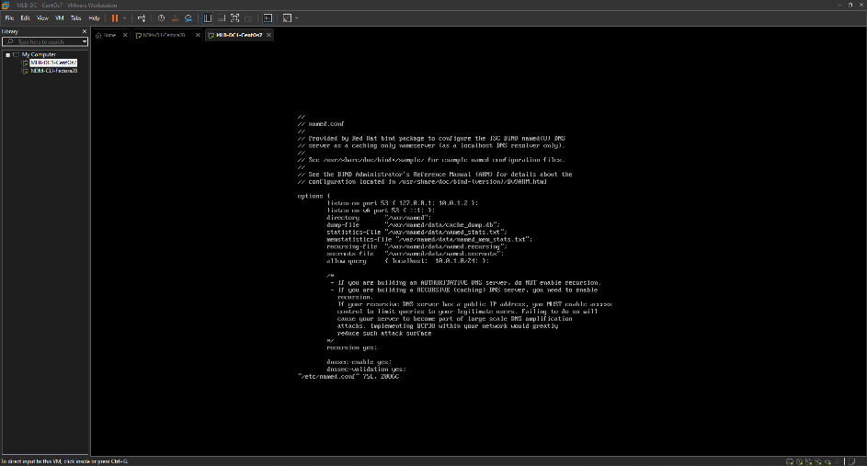

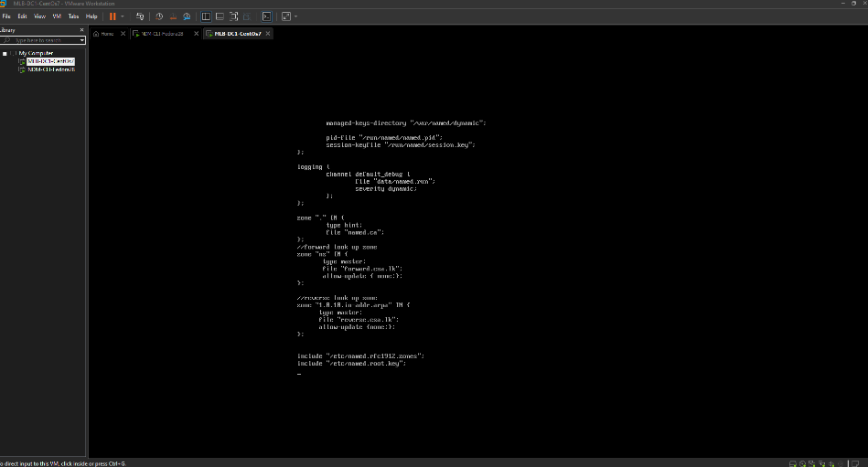

1. Open a new file named forward.csa.lk in the named directory as follows to create the forward zone file for the DNS server.

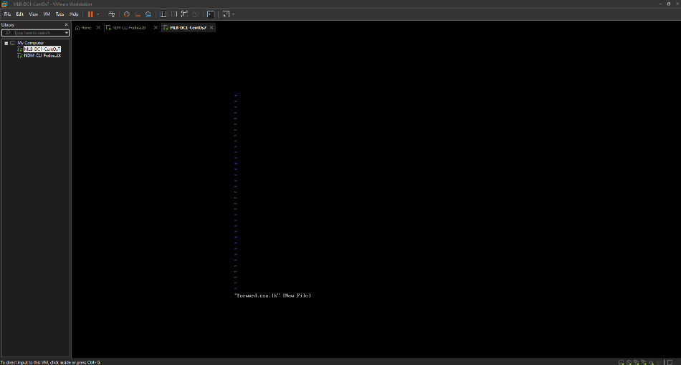

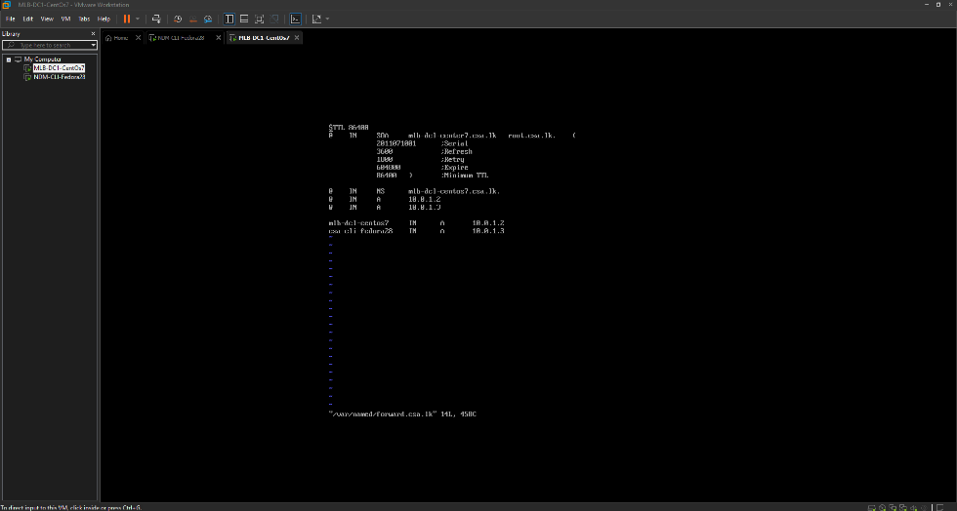

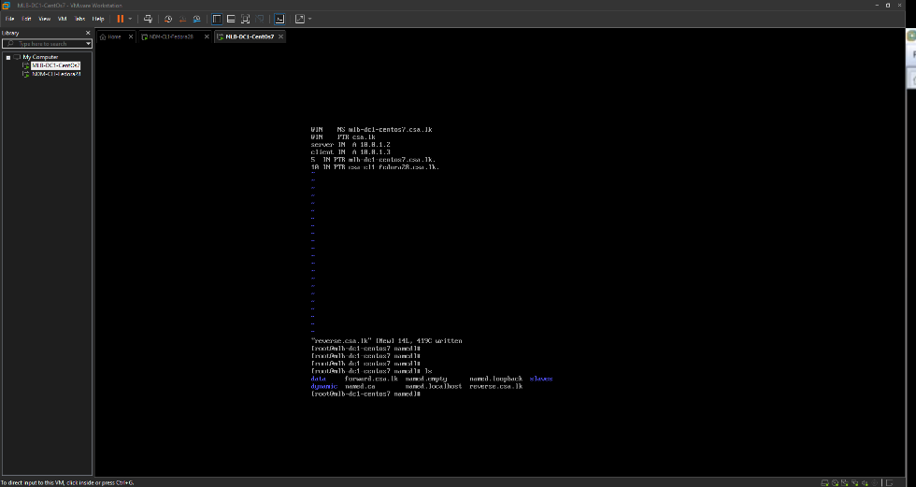

1. Open a new file named reverse.csa.lk in the named directory as follows to create the forward zone file for the DNS server.

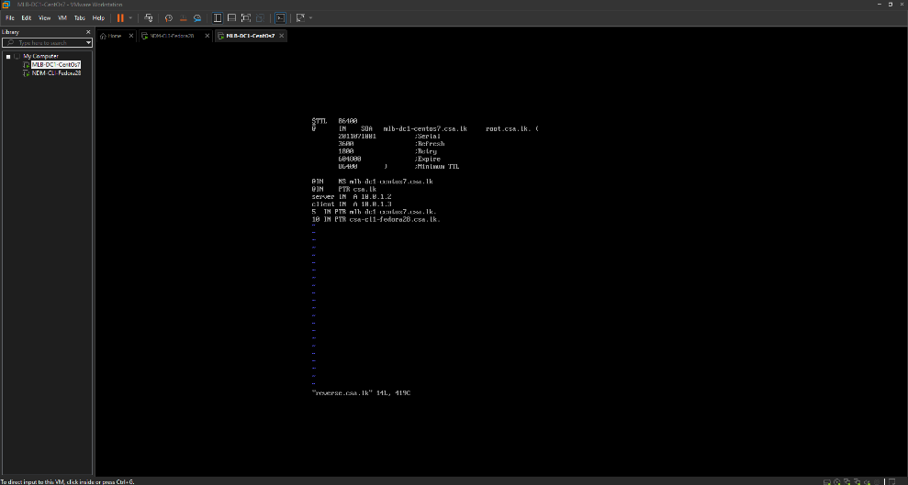

1. Stop your name server service and dhcp service if they are running.

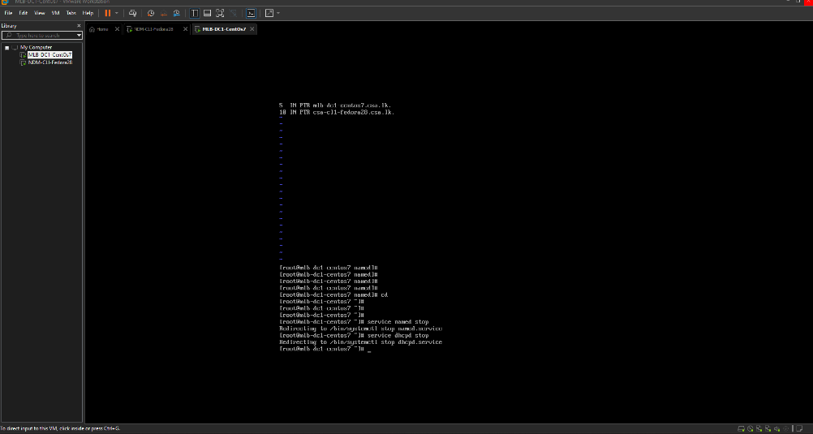

1. 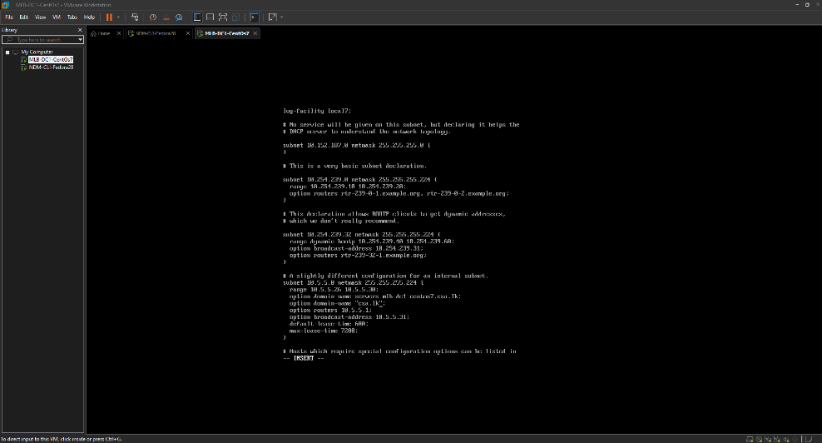Open and edit dhcpd.conf file,

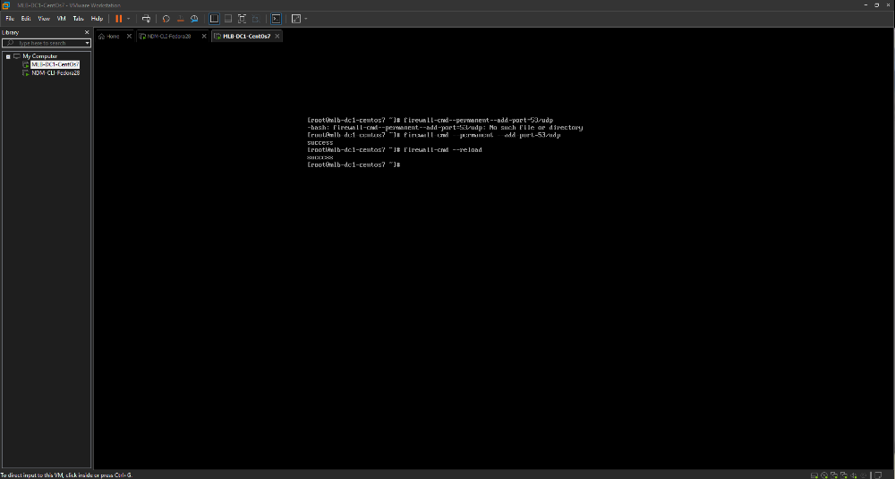06.Allow DNS communication via the CentOS firewall by adding a rule for UDP port 53. Switch to the root account and issue the command.

1. Test DNS configuration and zone files for any syntax errors as follows,

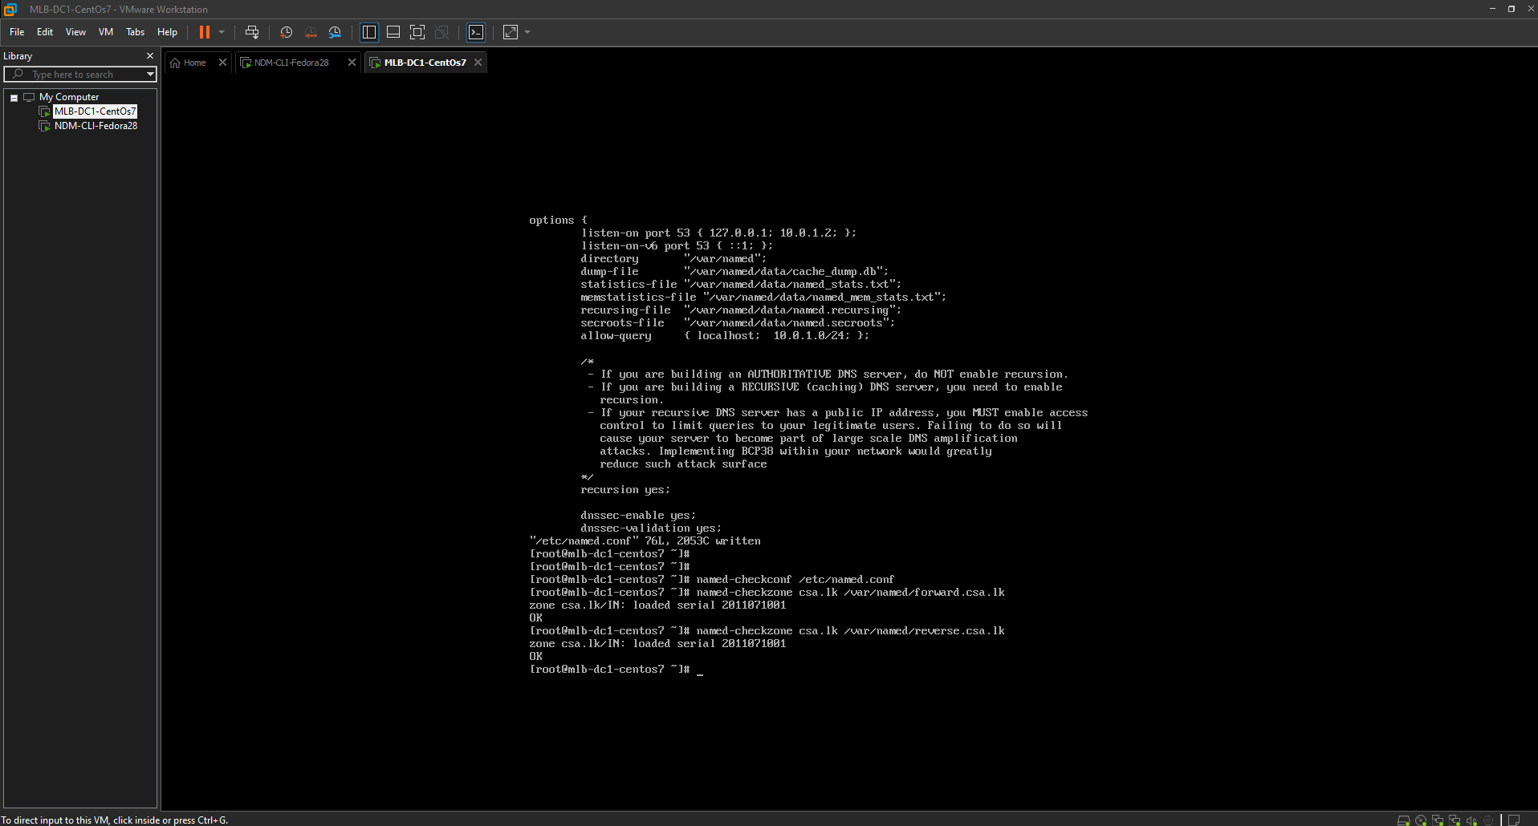

07.Active DNS and DHPD

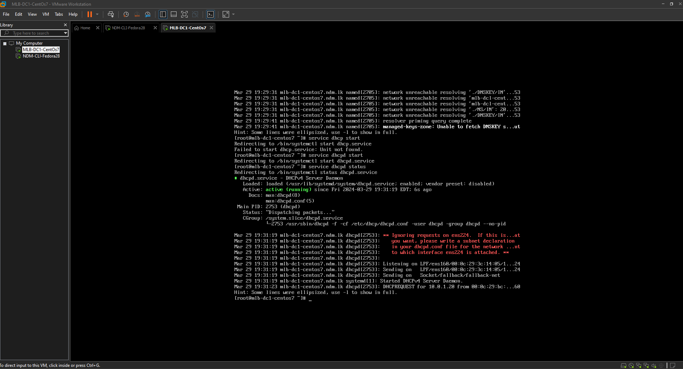

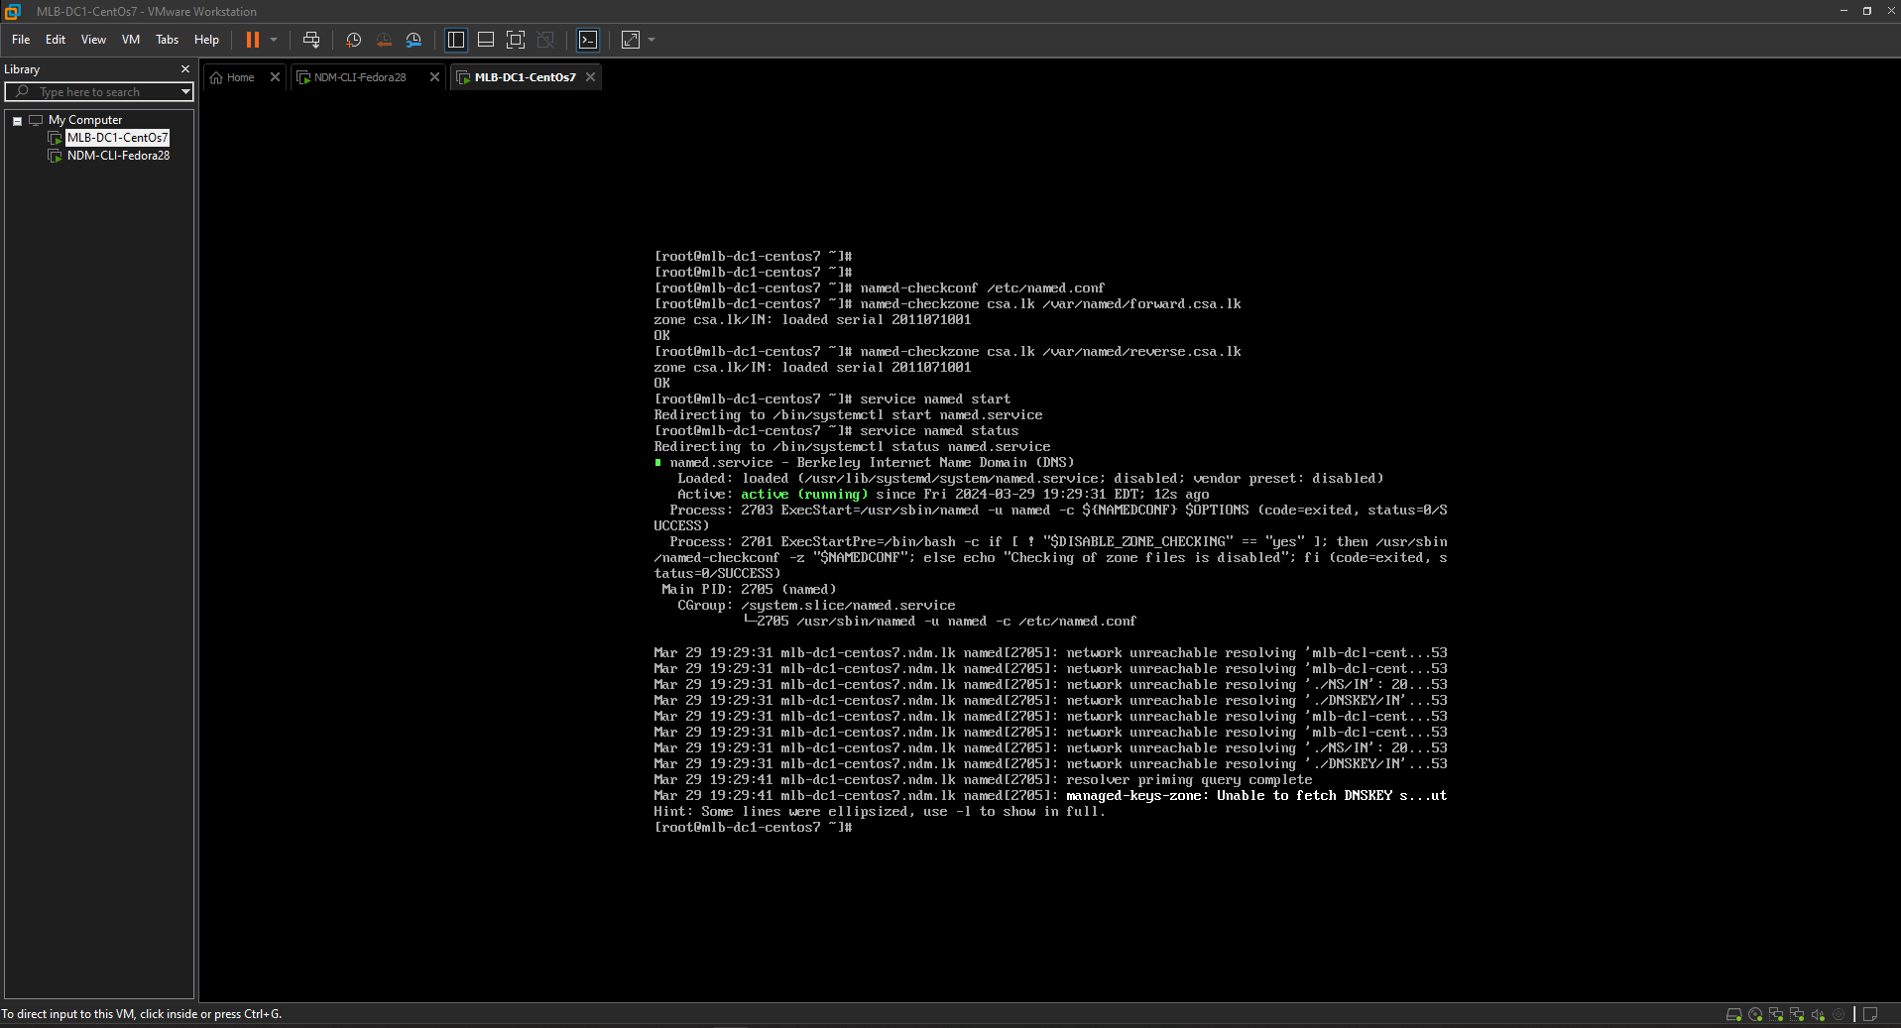

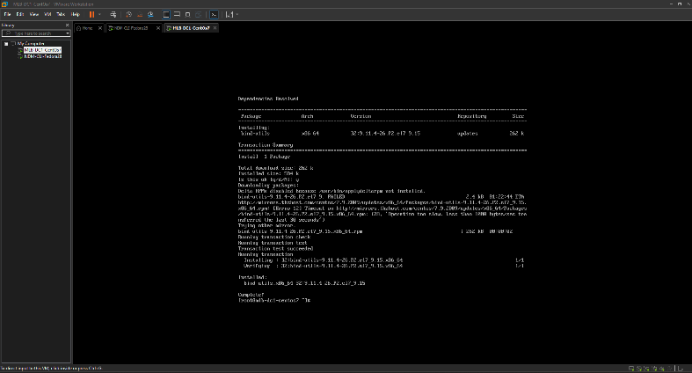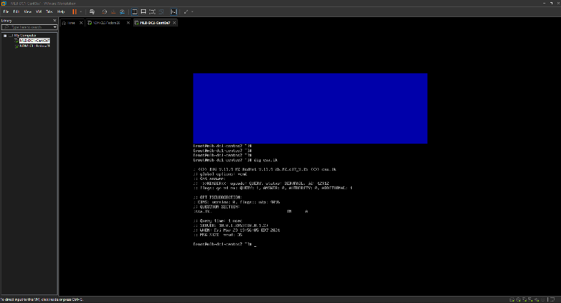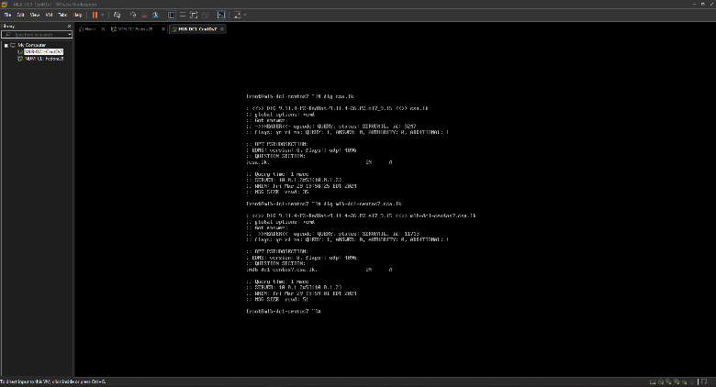

08.yum install bind-utils